Experiment 06
Study of Transmission Media

Lab Objective:
To study and understand different types of transmission media used in computer networking, including their characteristics, advantages, disadvantages, and usage scenarios.

Prerequisites:
- Basic knowledge of networking concepts (like LAN, WAN, topology).
- Understanding of data transmission principles (analog/digital, bandwidth, signal attenuation).

Outcome:
By the end of this experiment, students will be able to:
- Identify different types of transmission media.
- Describe their working principles.
- Compare advantages, limitations, and usage scenarios of each.

Transmission Media in Networking
Transmission media refers to the physical or wireless pathway through which data is transmitted from one device to another in a network. It is broadly classified into two main types:

1. Guided Media (Wired Transmission)
Data signals are guided through a physical medium such as cables.
a) Twisted Pair Cable
- Description: Consists of pairs of insulated copper wires twisted together.
- Types:
  - UTP (Unshielded Twisted Pair) – Used in LANs.
  - STP (Shielded Twisted Pair) – Provides better noise resistance.
- Characteristics:
  - Speed: Up to 10 Gbps (Cat6 or higher).
  - Max Length: ~100 meters.
  - Cost: Low.
- Usage: Telephone lines, LAN cables (Ethernet).
- Advantages: Cheap, flexible, easy to install.
- Disadvantages: Susceptible to EMI and crosstalk.
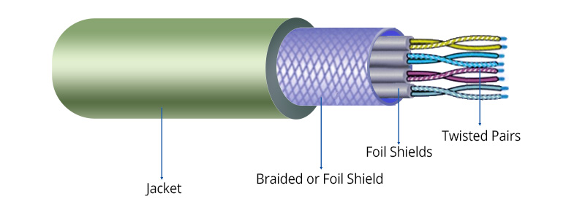

b) Coaxial Cable
- Description: Copper core surrounded by insulation and shielding.
- Characteristics:
  - Speed: Moderate (10-100 Mbps).
  - Distance: Up to 500 meters.
  - Cost: Moderate.
- Usage: Cable TV, older Ethernet networks.
- Advantages: Better noise resistance than twisted pair.
- Disadvantages: Bulkier and more expensive.
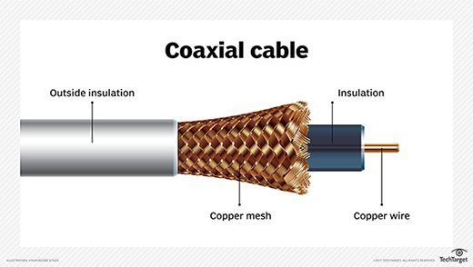

c) Optical Fiber Cable
- Description: Uses light signals to transmit data via glass or plastic fibers.
- Types:
  - Single-mode fiber – Long distance.
  - Multi-mode fiber – Short distance.

- Characteristics:
  - Speed: Extremely high (Gbps to Tbps).
  - Distance: Several kilometers.
  - Cost: High.
- Usage: Internet backbone, ISPs, data centers.
- Advantages: Immune to EMI, high bandwidth.
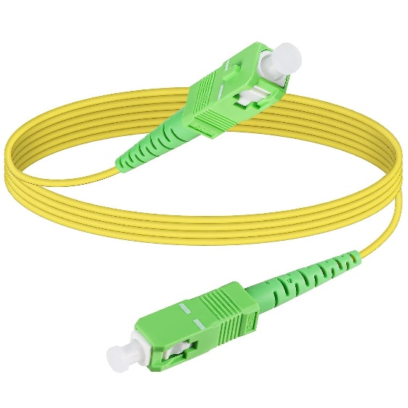
- Disadvantages: Expensive, difficult to install/repair.

2. Unguided Media (Wireless Transmission)
Uses the air or vacuum to transmit signals.
a) Radio Waves
- Description: Electromagnetic waves with long range and good penetration.
- Frequency: 3 kHz – 1 GHz.
- Usage: AM/FM radio, mobile phones, wireless LANs.
- Advantages: Long range, no cables needed.
- Disadvantages: Susceptible to interference.
b) Microwaves
- Description: Travel in straight lines, require line-of-sight.
- Frequency: 1 GHz – 300 GHz.
- Usage: Satellite communication, mobile networks.
- Advantages: High bandwidth.
- Disadvantages: Affected by weather, needs alignment.
c) Infrared
- Description: Short-range wireless communication using light signals.
- Usage: Remote controls, short-distance file transfer (IR).
- Advantages: Secure in closed rooms.
- Disadvantages: Cannot penetrate walls.
d) Satellite Communication
- Description: Uses satellites to relay signals over long distances.
- Usage: Global internet access, GPS, DTH.
- Advantages: Very long-distance coverage.
- Disadvantages: Expensive, weather-dependent, high latency.

Comparison Table:
Media Type | Speed | Cost | Distance | EMI Resistance | Common Use
Twisted Pair | Up to 10 Gbps | Low | ~100m | Low | LAN, telephone
Coaxial Cable | Moderate | Medium | ~500m | Medium | Cable TV
Optical Fiber | Very High | High | >10 km | High | Internet backbone
Radio Waves | Moderate | Low | Long | Low | Wi-Fi, radio, cell phones
Microwaves | High | Medium | Long (LoS) | Medium | Satellites, microwave links
Infrared | Low | Low | Very Short | High | Remote controls
Satellite | Moderate | Very High | Global | High | GPS, DTH, global internet

Conclusion:
Transmission media plays a vital role in determining the speed, range, cost, and reliability of a network. Choosing the right media depends on:
- Distance
- Data speed requirement
- Budget
- Environment (indoor/outdoor)

